5.7 Divergence Theorem Worksheet

- Suppose and is the sphere of radius 2 centered at the origin. Use the Divergence Theorem to calculate the flux of F across .

- Let . Determine the flux across the surface of the unit cube existing entirely within the first octant with outward orientation.

- Let and be the surface of the solid bounded above by the paraboloid and below by the plane . Determine the flux across with outward orientation.

- Let and consider the solid E formed by the following four surfaces:
- : given by where
- : given by
- : given by
- : given by the xy-plane

- Determine the flux of F through with respect to inward normals.

- The solid E was made from four surfaces as stated above. The flux of F through exactly two of , , and is exactly 0. Determine which of these corresponds to a nonzero flux.

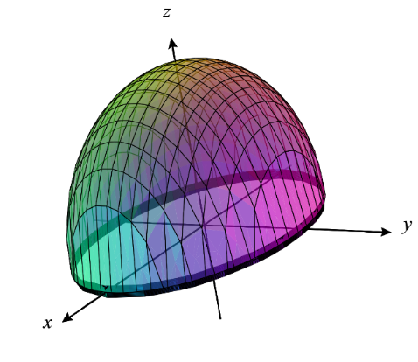
- Set up, but do not evaluate, a triple integral which represents the flux of F across where and is the surface of the solid within the elliptical cylinder bounded above by the ellipsoid and bounded below by the plane with outward orientation.

- Suppose G is a simple solid region in and let be the boundary surface of G, given with positive orientation. Suppose you are told G has a volume of 10. If an object of constant density occupies the region G, then prove that where is the x-coordinate of the center of mass of the solid.

